OR Preparation for Adult Patients with Epidermolysis Bullosa (EB)
Pilfered from Louise K. Furukawa MD
Edited by Erin Bushell, MD and Brita Mittal, MD
2017

Background:
Patients with EB have a mutation in their keratin or collagen genes. As a result the skin is not properly anchored and mere touch can cause the skin to slough or blister. Many different subtypes have been identified but the most common variant we see in our patient population is recessive dystrophic EB. They may appear as burn patients and are frequently wrapped in total body burn dressings. NO ADHESIVES MAY BE USED IN THESE PATIENTS. You will note the following in these patients:

Airway: the tissues of the lining of the mouth, tongue and esophagus are affected making eating difficult. Mouth opening is SEVERELY LIMITED and these patients are always considered difficult airways. FOI is the preferred method to intubate since we try to minimize contact with the mucosa.

Digits: continued skin slough and scarring results in absence of fingernails and the fingers often fuse together.

Cardiac: Over time, some patients develop a cardiomyopathy. Anemia is common as is continued infections, so these patients often appear to be in a high-output state.
Renal: Many patients develop renal failure over time.

Hemotologic: Continued bleeding from wounds and poor nutrition causes anemia.

Infections: These patients are often colonized with MRSA in their wounds and many act as though in low-grade sepsis. You will see tachycardia and anesthetic resistance.

IV access: Difficult though not as impossible as you would imagine. NO ELASTIC TOURNIQUETS! A hand tourniquet is sufficient. Alcohol wipes are not usually used. A small amount of baby shampoo on moistened gauze dabbed on and off with moist gauze may be used

GI tract: Esophageal strictures are common due to sloughing and scarring of the esophagus, so patients coming in for these procedures often cannot handle their oral secretions and are drooling.

Skin: Raw patches, oozing wounds, multiple dressings, often smelly wounds. Please note that shear stress on the skin is worse than pressure in causing blisters.

It is imperative that we conduct our anesthetic in a way that is as delicate as possible. The following guidelines will help when assisting with the set-up of a room for a patient with EB.

OR Bed:
The patient needs to lie on a sheepskin. Currently these are not real sheepskin, but synthetic equivalents. Generally though, if the patient has been placed on a gurney he/she will already by lying on a sheepskin and this proves useful for transfers onto the OR bed. Please have a sheepskin in an UNOPENED package in the OR in case the patient doesn’t have one.

Monitors
- EKG: We cannot stick EKG pads on the patients. What works very well is to use the old orange defibrillator gel pads and place the EKG stickers upon that. Cut 3 2”X2” defib pad chunks and have them ready to place on the patient. Cover this all with moist 2x2s to prevent the defib pads from drying out.

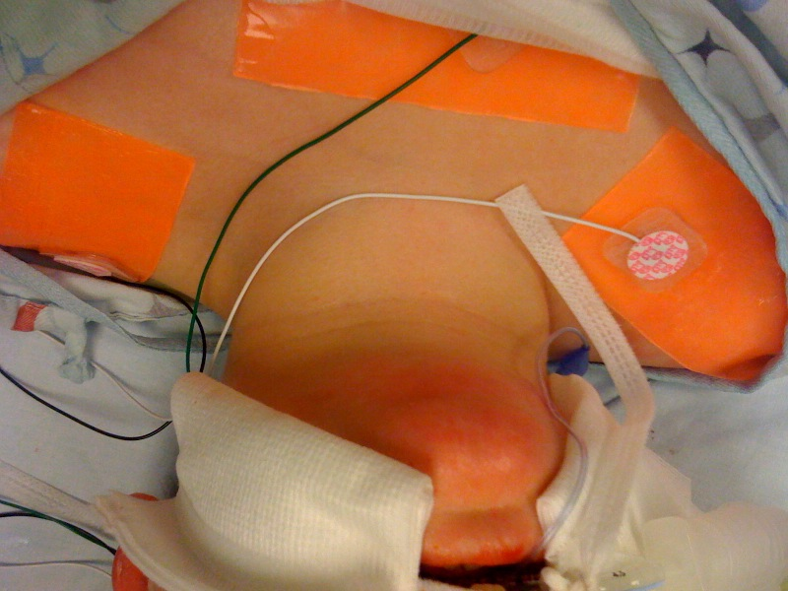

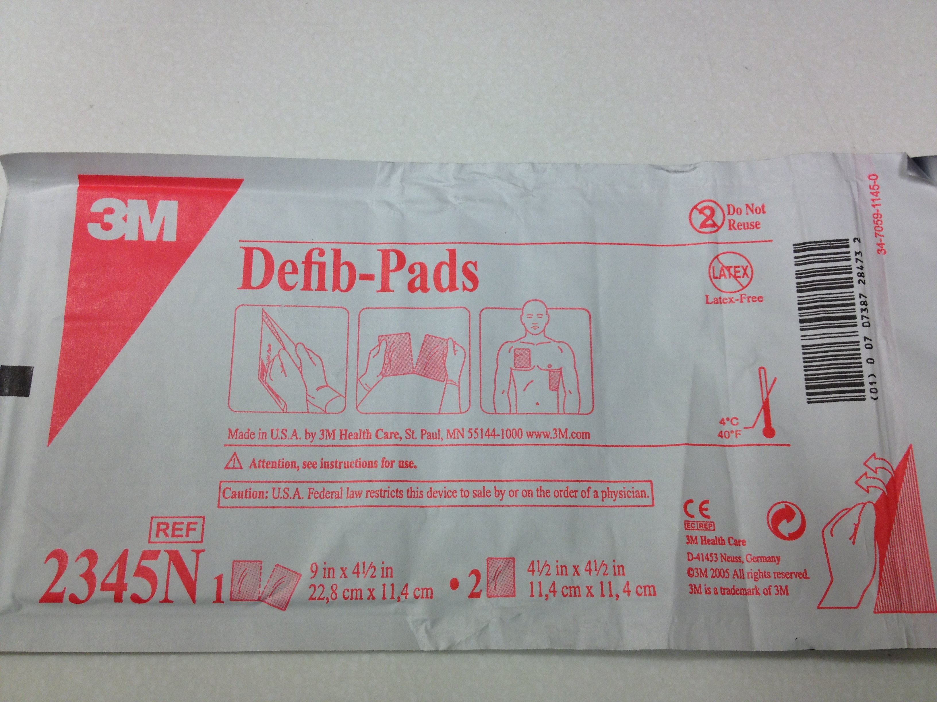

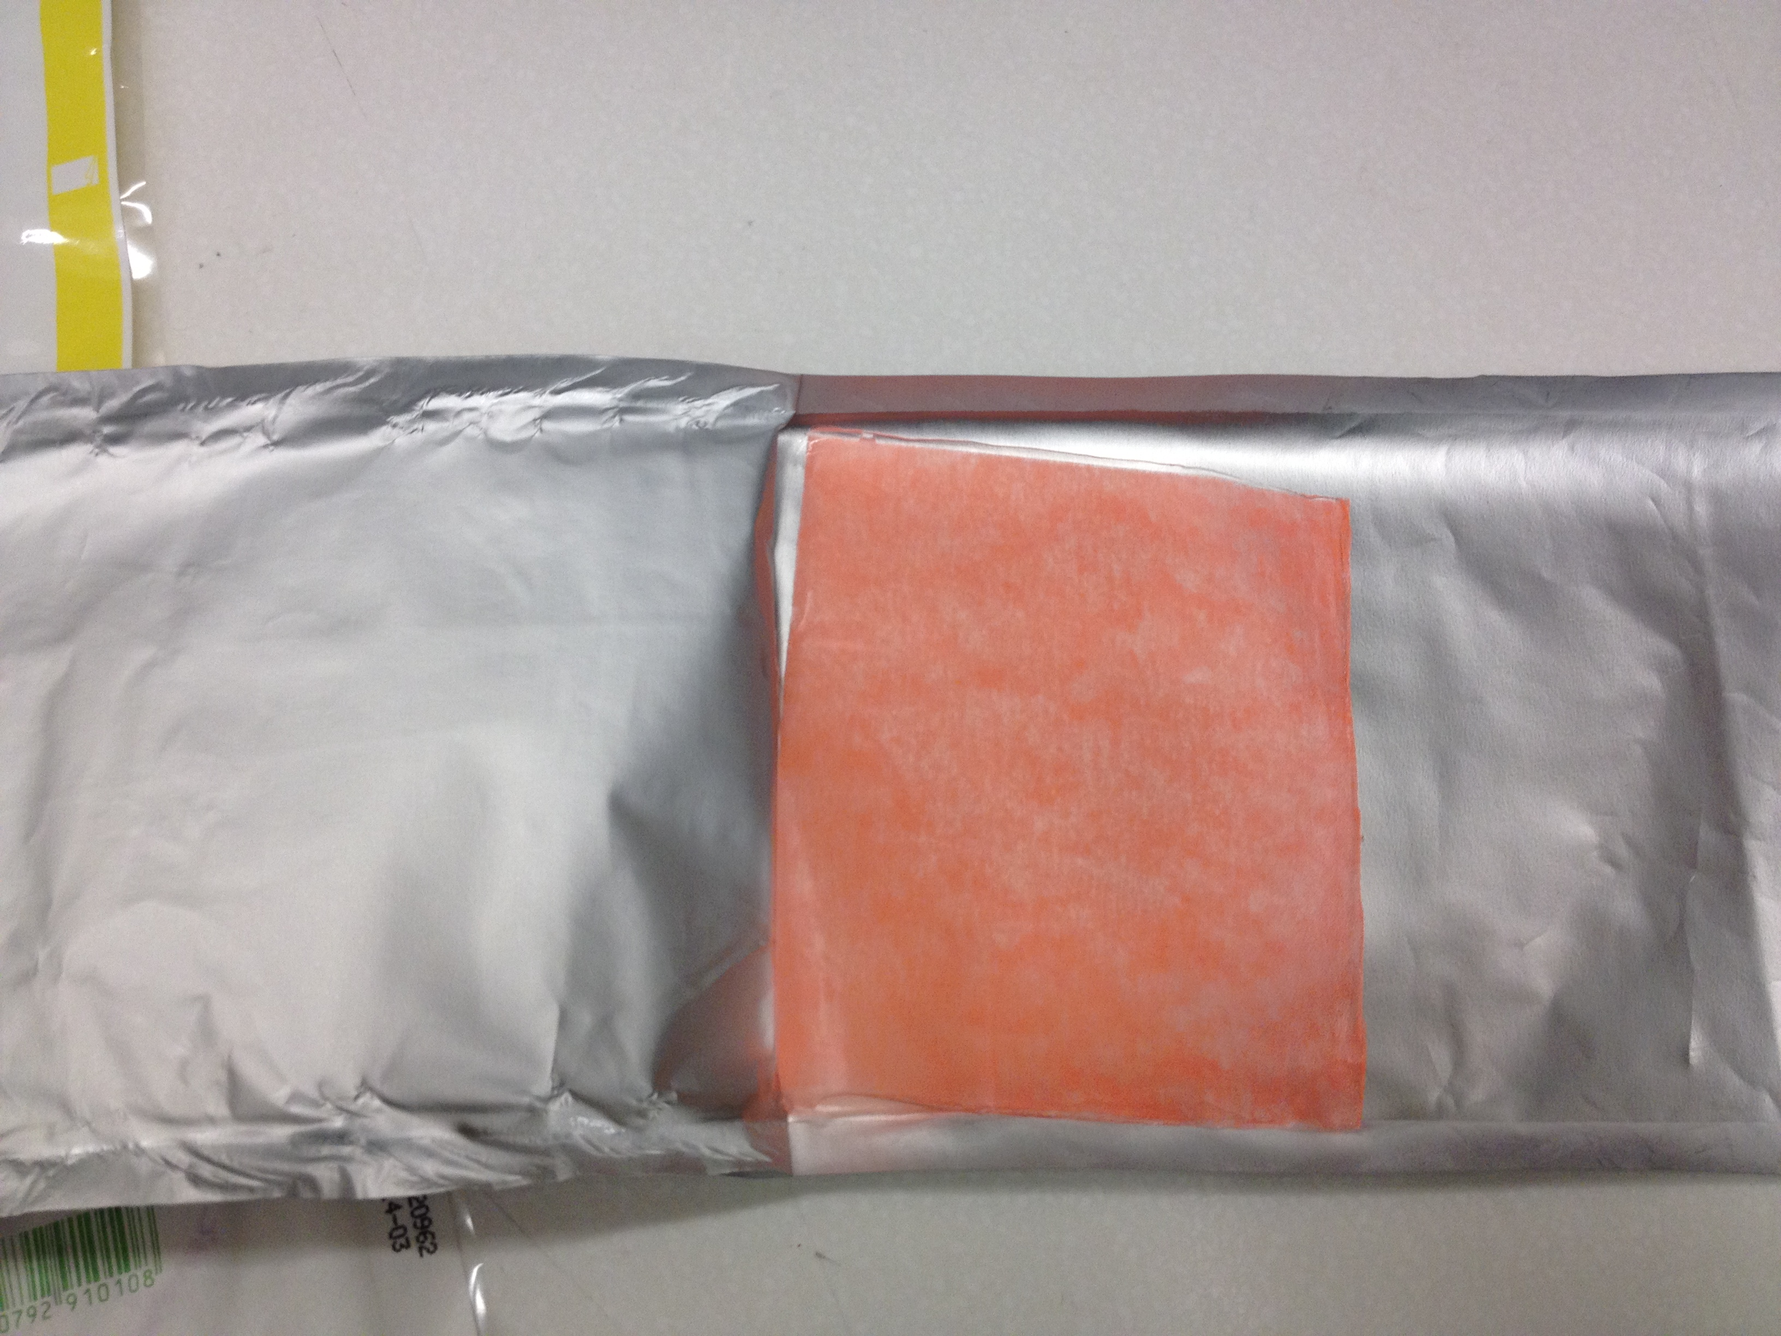

- Pulse ox: We cannot have adhesive on the patients digits (or stumps), so place tegaderms onto the pulseox adhesive (sticky side to sticky side) and cut off excess tegaderm. The now non-sticky pulseox is wrapped around the digit and held in place by 1-inch coban.

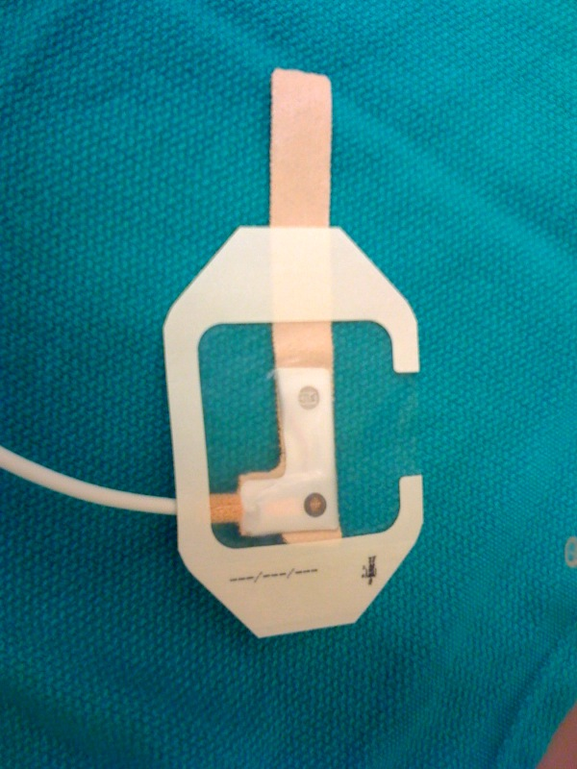

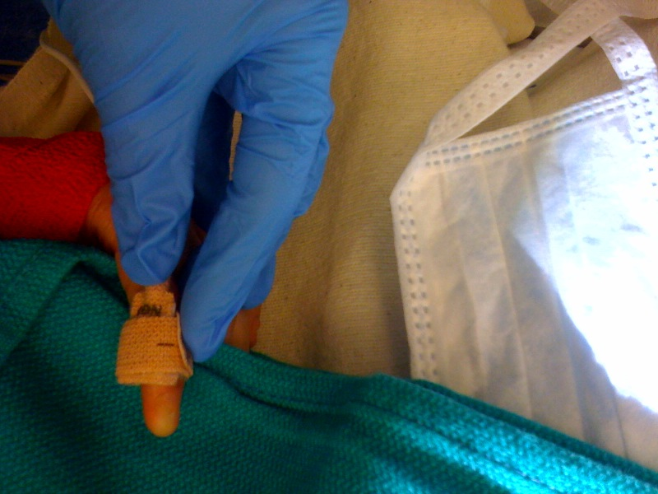

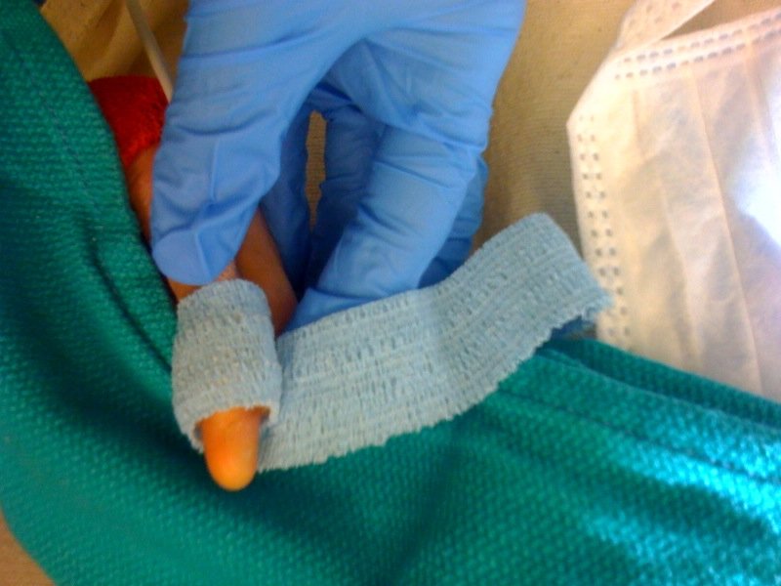

- Blood Pressure Cuff:
Webril must be placed on the patient’s extremity prior to the application of the BP cuff. Try not to get any creases or wrinkles in the coban. If the wounds are extensive, placing the BP cuff right over the dressing works too.

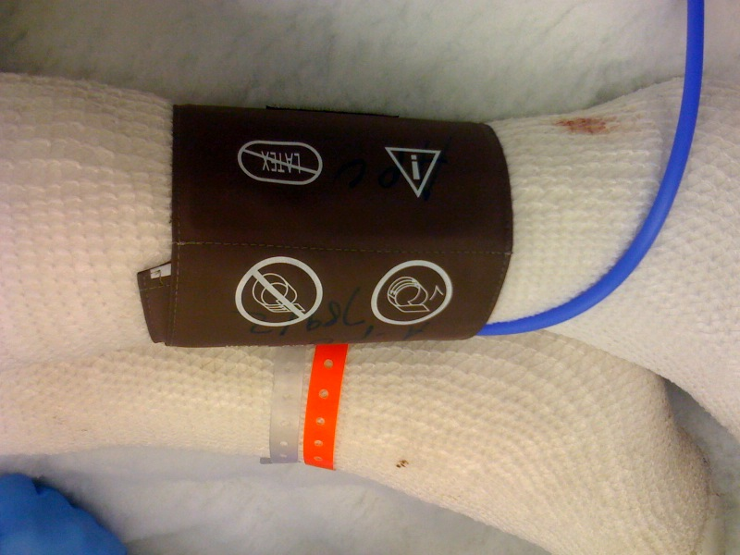
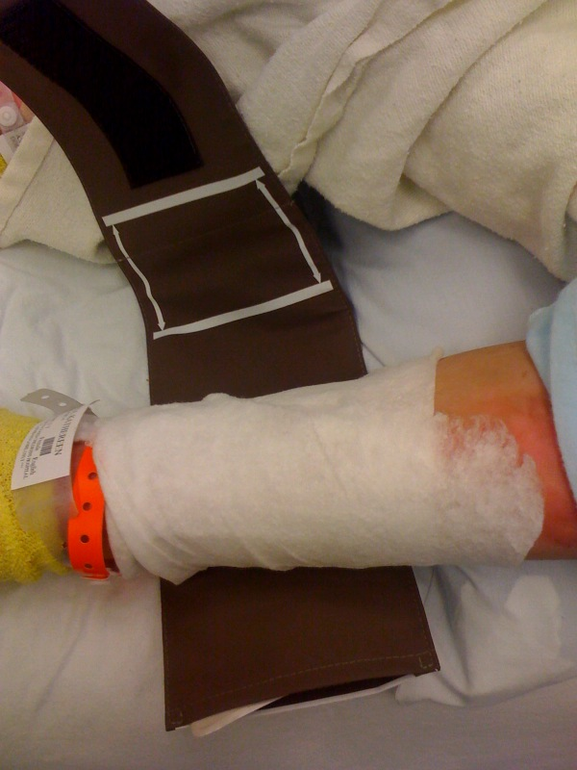
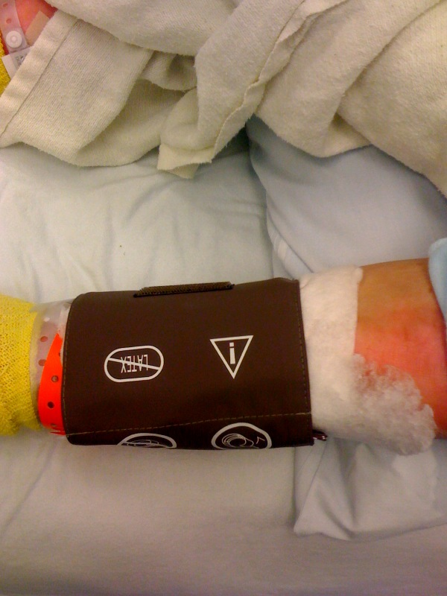

Eye protection:

- We tend to use preservative free methylcellulose drops (Refresh) on the eyes. (order from pharmacy--have tube to station 737 for IR, 209 for endo)
A small amount of ocular lubricant and use of mepitel sheeting (acting as a “tape” of sorts) will keep the eyes lubricated, shut, and protected. Put moist 2x2 over the mepitel. Use of ocular lubricant alone with no eye covering can result in objects falling into the eye (such as the ETT pilot balloon)

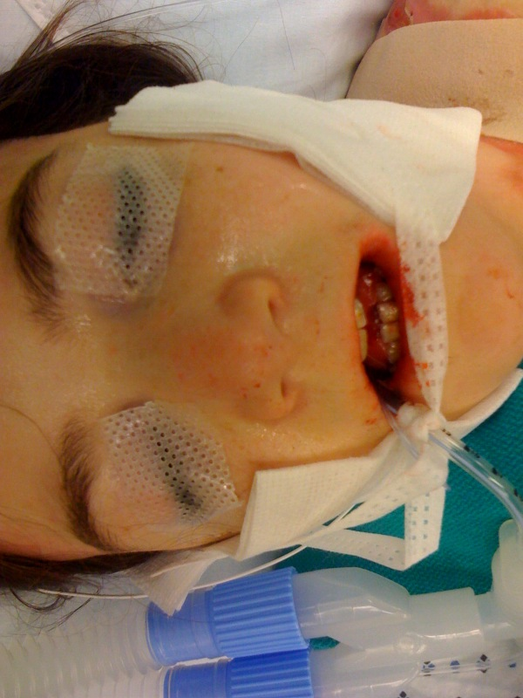

Airway Management:

If possible we try not to manipulate the airway. Cases such as a hand dressing change can likely be done without intubation. Cases such as esophageal dilation and gastrostomy tube placement must be done with intubation. In either case, be prepared for a FOI.

- Anesthesia Circuit Mask: the mask must be FULLY INFLATED with air, otherwise, pressure on the face of the hard portions of the mask will cause blistering. The mask must be liberally slathered with Aquaphor ointment (order from pharmacy--have tube to station 737 for IR, 209 for endo)
- Because many patients have difficult IV access or extreme anxiety, we will not infrequently mask induce younger adults. Otherwise, access is usually obtained in the IR or endo suite using US.
- If doing an IV induction: use the optiflow to preoxyenate. Increase flows once patient is asleep. Vaseline gauze and mepilex transfer foam are placed on both sides of the mandible to allow for reduced stress with jaw thrust.
- Once the patient is induced, we usually convert to an IV anesthetic to assist with FOI
- A tiny oral airway inserted between the teeth is often helpful in preventing biting on the fiberoptic bronchoscope.
- Secretions are often a problem during the FOI
- We often use small tubes during these intubations. The patients are also typically small for age.
- Once the tube is in position it is secured by using ties. Different anesthesiologists have different favorite techniques so please ask how they prefer to do this. In the above picture a surgical mask is placed behind the head. Where the ties cross the cheeks an ample amount of Aquaphor ointment is place on gauze and used to protect the skin. The mask ties are then secured to the tube. Still, this is not super-secure, so the anesthesiologist or assistant needs to hold the tube in place if an endoscope (for esophageal dilation) is advanced through the mouth.

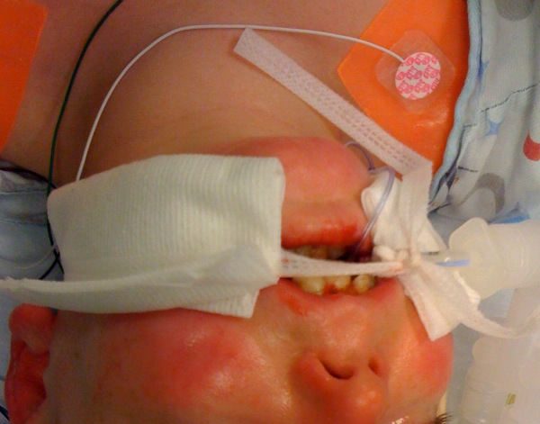
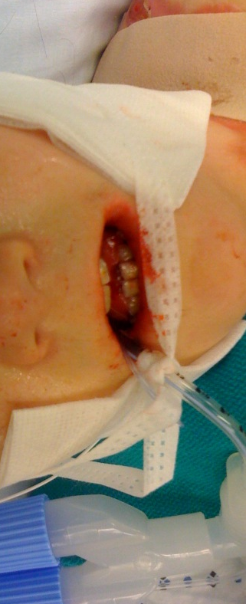

IV Access:
As mentioned before, difficult but not impossible. We usually ask the patient where they’ve had good luck with IVs in the past. When establishing IV access please DO NOT USE ELASTIC TOURNIQUETS! WE use only a hand tourniquet. Alcohol wipes are not usually used. A small amount of baby shampoo on a moistened gauze and wiped off with moist gauze may be used. Once the IV is in, place a small amount of mepitel sheeting or mepitac under the IV hub to prevent pressure on the skin, then secure with a coban. If the patient has tough skin you may use mepitac as “tape” to hold the IV onto the skin. Wrap the entire IV in coban and secure well.

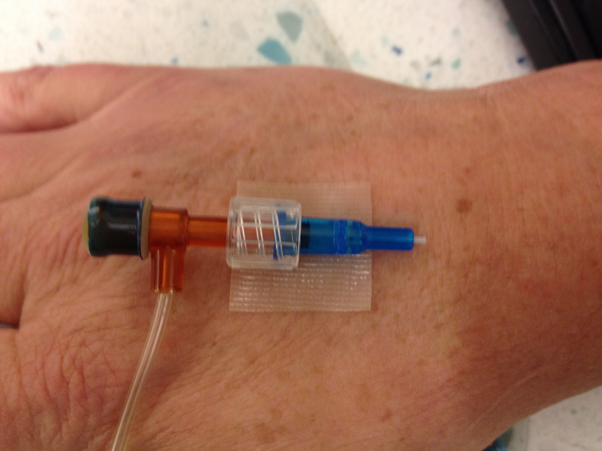

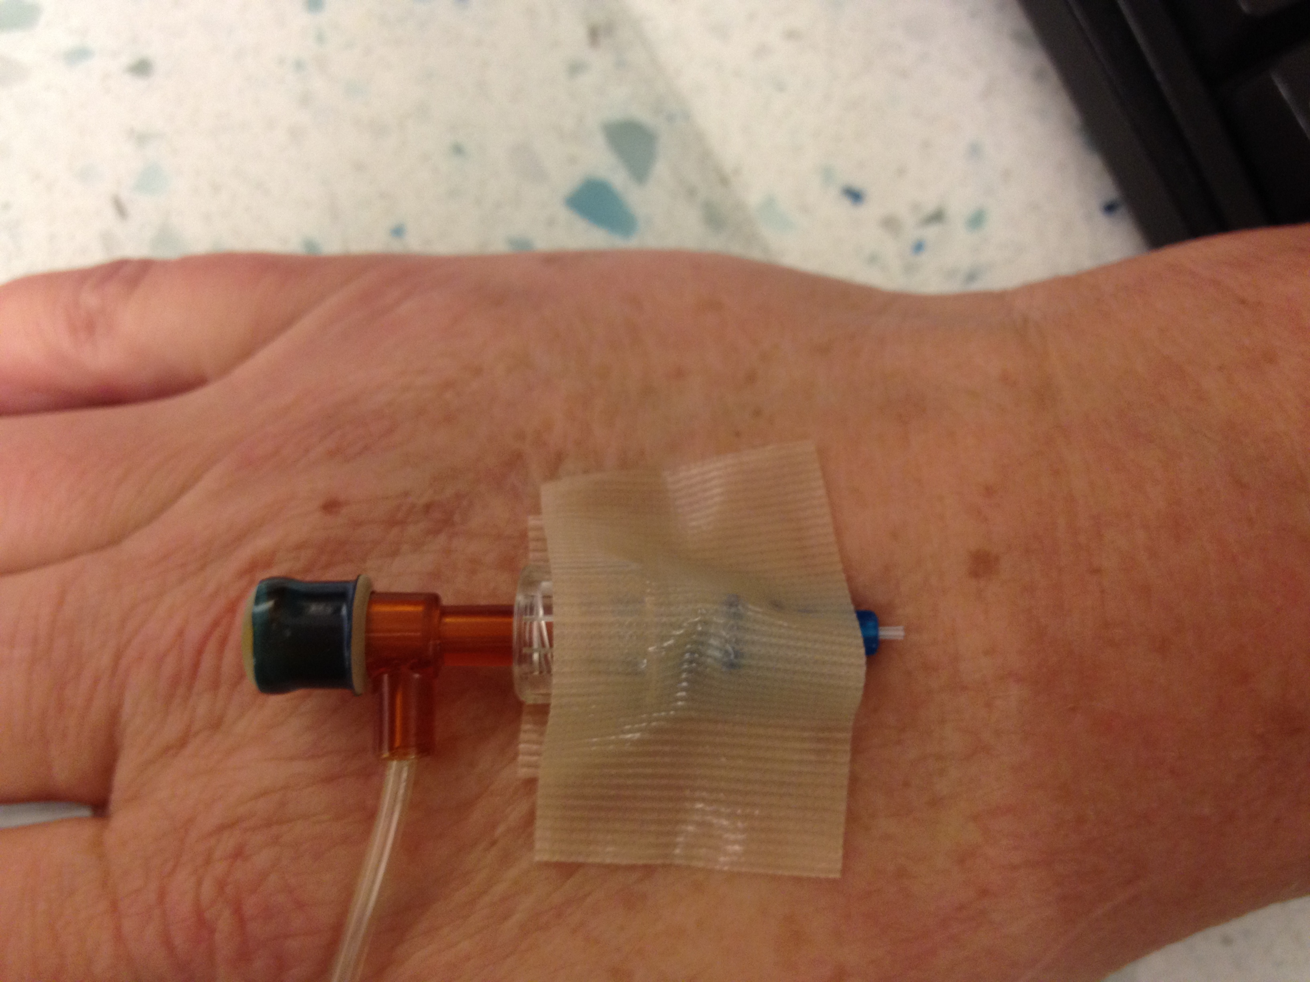

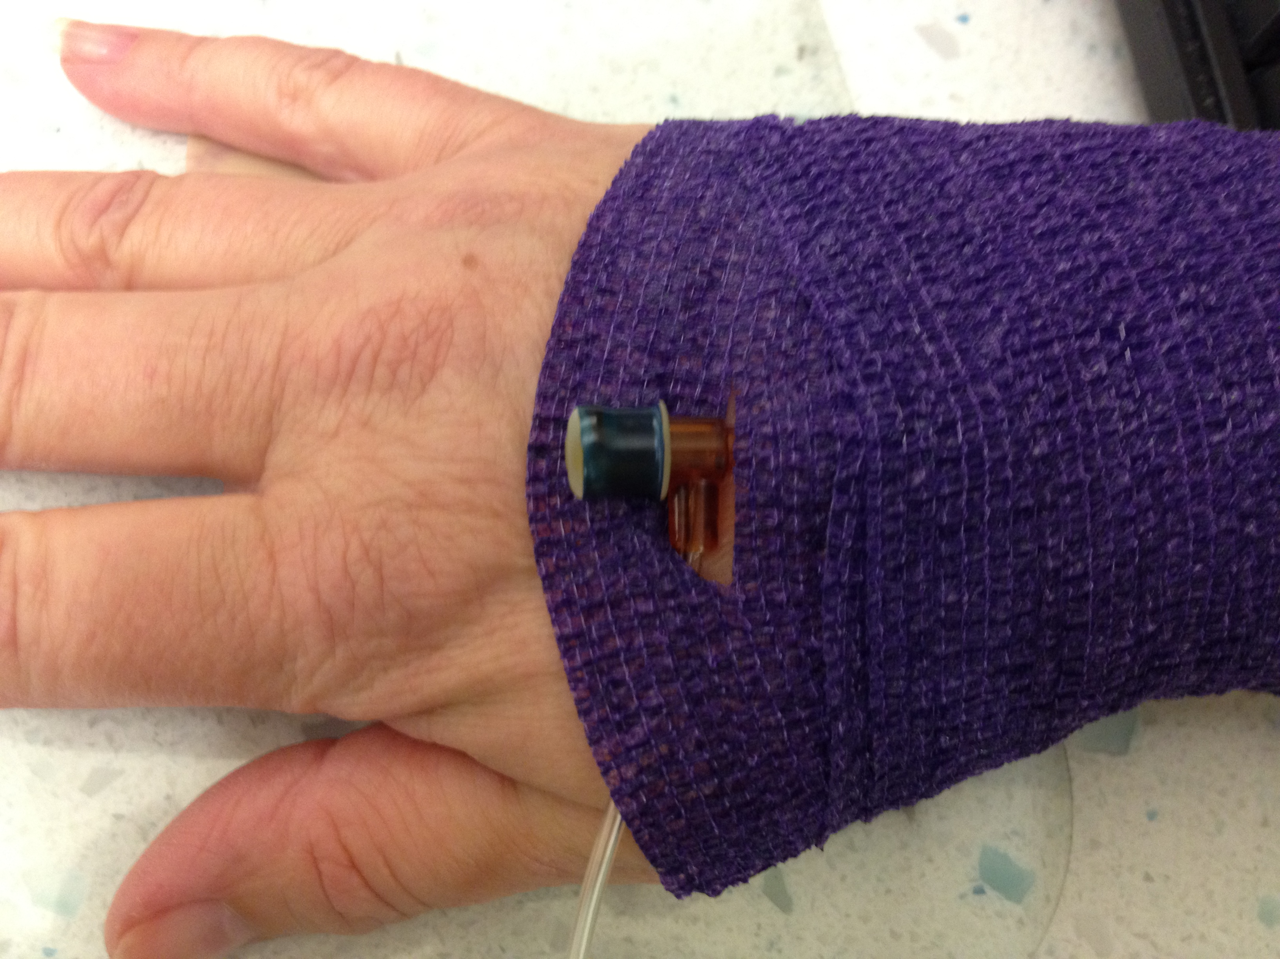

Products:

